**ONLINE SHOPPING SYSTEM**

Use case diagram:

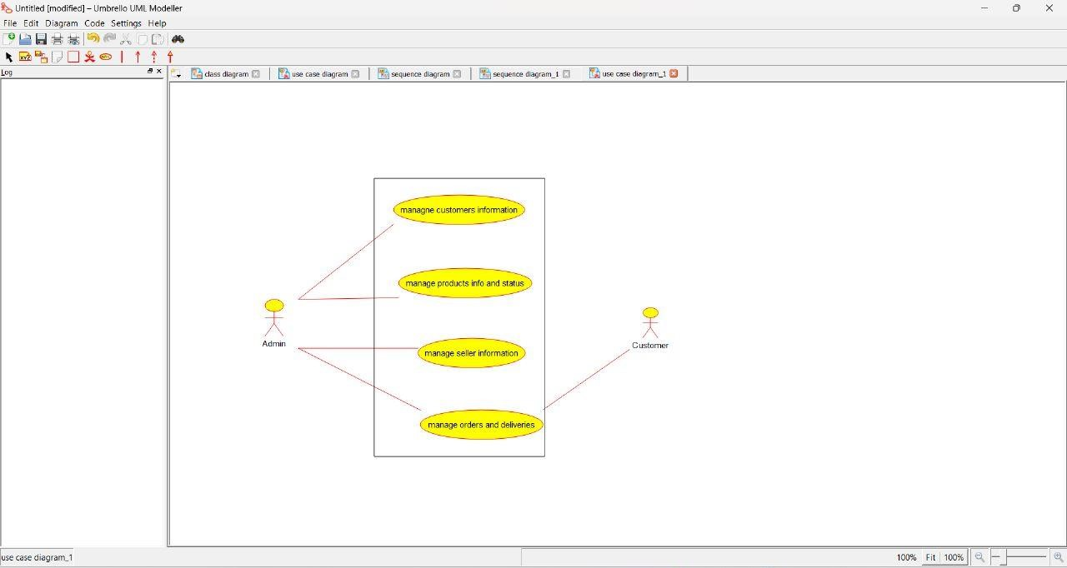

Activity diagram:

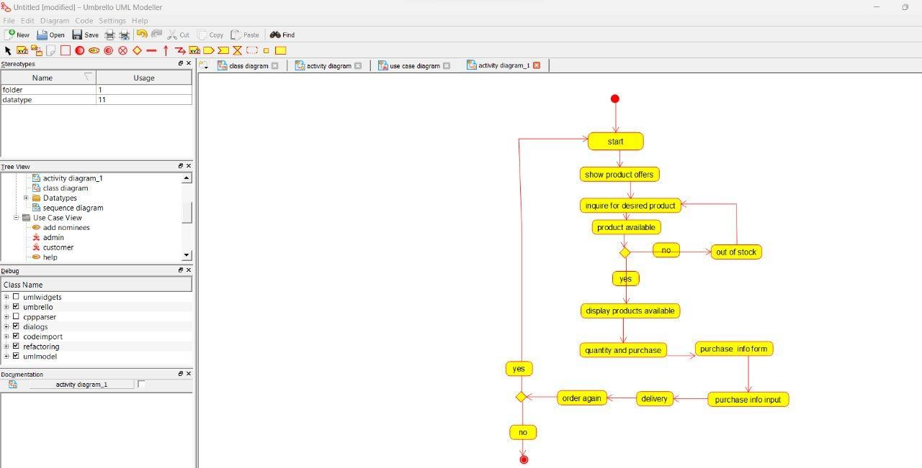

Sequence diagram:

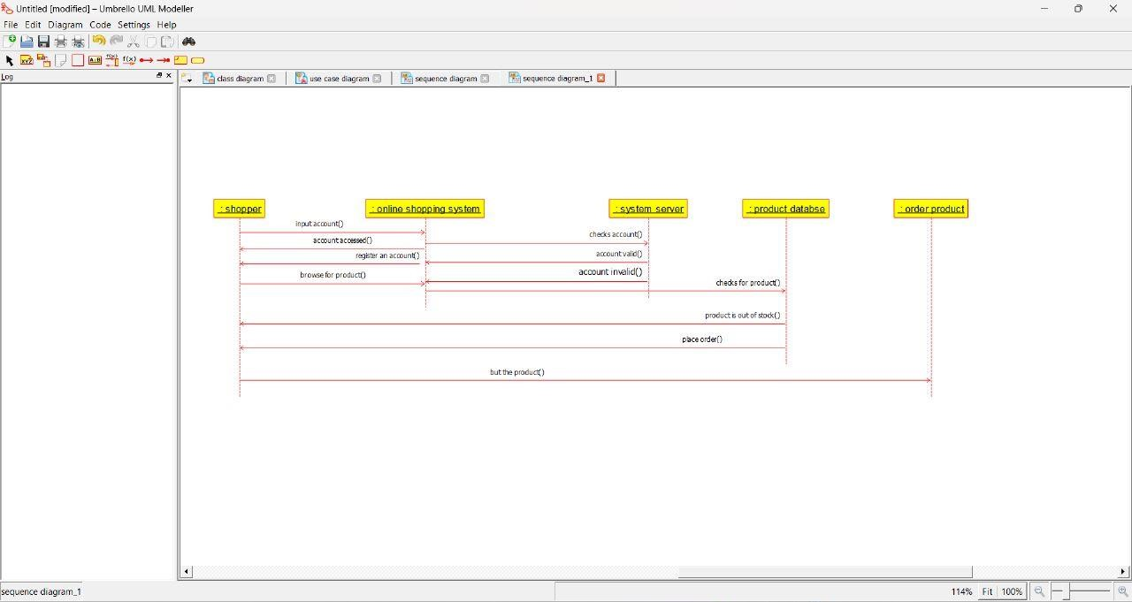

Object diagram:

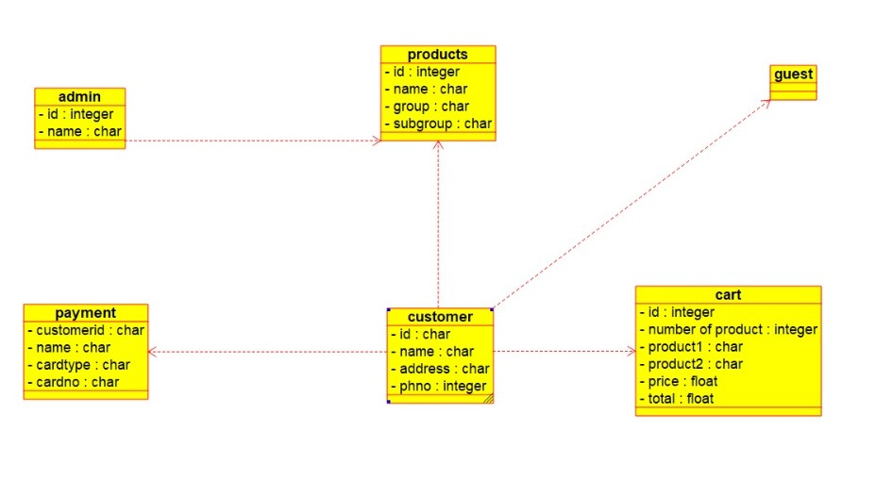

Component diagram:

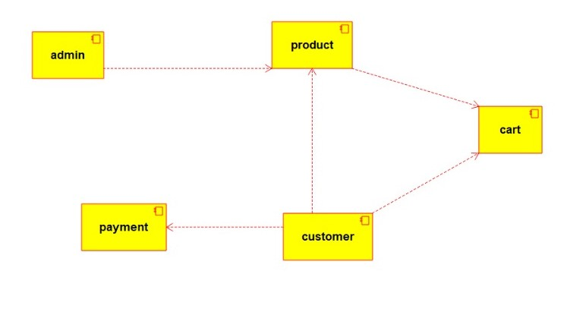

Collaboration diagram:

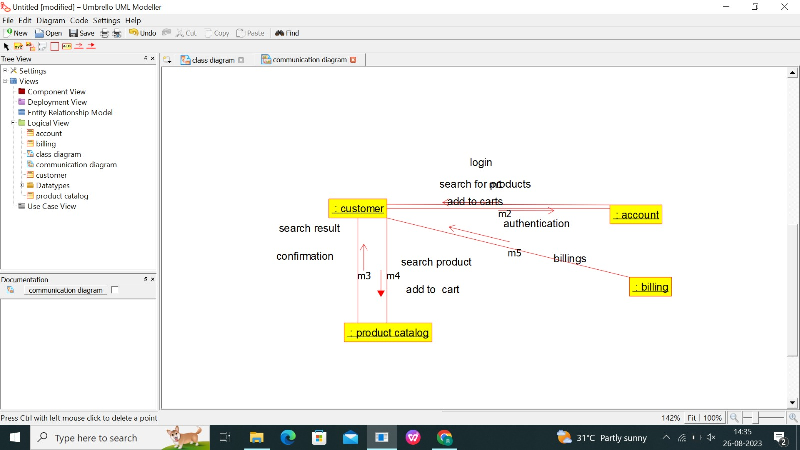

Deployment diagram:

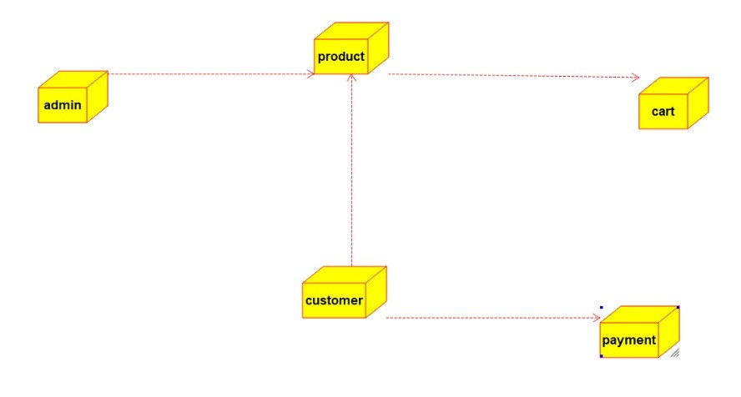

Program:

Admin

/**

* Class admin

*/

public class admin {

//

// Fields

//

private integer id;

private char name;

//

// Constructors

//

public admin () { };

//

// Methods

//

//

// Accessor methods

//

/**

* Set the value of id

* @param newVar the new value of id

*/

private void setId (integer newVar) {

id = newVar;

}

/**

* Get the value of id

* @return the value of id

*/

private integer getId () {

return id;

}

/**

* Set the value of name

* @param newVar the new value of name

*/

private void setName (char newVar) {

name = newVar;

}

/**

* Get the value of name

* @return the value of name

*/

private char getName () {

return name;

}

//

// Other methods

//

/**

*/

public void view_product()

{

}

/**

*/

public void add_product()

{

}

/**

*/

public void delete_product()

{

}

/**

*/

public void modify_product()

{

}

/**

*/

public void make_shipment()

{

}

/**

*/

public void confirm_delivery()

{

}

}

Payment:

/**

* Class admin

*/

public class admin {

//

// Fields

//

private integer id;

private char name;

//

// Constructors

//

public admin () { };

//

// Methods

//

//

// Accessor methods

//

/**

* Set the value of id

* @param newVar the new value of id

*/

private void setId (integer newVar) {

id = newVar;

}

/**

* Get the value of id

* @return the value of id

*/

private integer getId () {

return id;

}

/**

* Set the value of name

* @param newVar the new value of name

*/

private void setName (char newVar) {

name = newVar;

}

/**

* Get the value of name

* @return the value of name

*/

private char getName () {

return name;

}

//

// Other methods

//

/**

*/

public void view_product()

{

}

/**

*/

public void add_product()

{

}

/**

*/

public void delete_product()

{

}

/**

*/

public void modify_product()

{

}

/**

*/

public void make_shipment()

{

}

/**

*/

public void confirm_delivery()

{

}

}

/**

* Class payment

*/

public class payment {

//

// Fields

//

private char customerid;

private char name;

private char cardtype;

private char cardno;

//

// Constructors

//

public payment () { };

//

// Methods

//

//

// Accessor methods

//

/**

* Set the value of customerid

* @param newVar the new value of customerid

*/

private void setCustomerid (char newVar) {

customerid = newVar;

}

/**

* Get the value of customerid

* @return the value of customerid

*/

private char getCustomerid () {

return customerid;

}

/**

* Set the value of name

* @param newVar the new value of name

*/

private void setName (char newVar) {

name = newVar;

}

/**

* Get the value of name

* @return the value of name

*/

private char getName () {

return name;

}

/**

* Set the value of cardtype

* @param newVar the new value of cardtype

*/

private void setCardtype (char newVar) {

cardtype = newVar;

}

/**

* Get the value of cardtype

* @return the value of cardtype

*/

private char getCardtype () {

return cardtype;

}

/**

* Set the value of cardno

* @param newVar the new value of cardno

*/

private void setCardno (char newVar) {

cardno = newVar;

}

/**

* Get the value of cardno

* @return the value of cardno

*/

private char getCardno () {

return cardno;

}

//

// Other methods

//

}

Cart:

/**

* Class admin

*/

public class admin {

//

// Fields

//

private integer id;

private char name;

//

// Constructors

//

public admin () { };

//

// Methods

//

//

// Accessor methods

//

/**

* Set the value of id

* @param newVar the new value of id

*/

private void setId (integer newVar) {

id = newVar;

}

/**

* Get the value of id

* @return the value of id

*/

private integer getId () {

return id;

}

/**

* Set the value of name

* @param newVar the new value of name

*/

private void setName (char newVar) {

name = newVar;

}

/**

* Get the value of name

* @return the value of name

*/

private char getName () {

return name;

}

//

// Other methods

//

/**

*/

public void view_product()

{

}

/**

*/

public void add_product()

{

}

/**

*/

public void delete_product()

{

}

/**

*/

public void modify_product()

{

}

/**

*/

public void make_shipment()

{

}

/**

*/

public void confirm_delivery()

{

}

}

/**

* Class cart

*/

public class cart {

//

// Fields

//

private integer id;

private integer no_of_products;

private char product1;

private char product2;

private char productn;

private float price;

private float total;

//

// Constructors

//

public cart () { };

//

// Methods

//

//

// Accessor methods

//

/**

* Set the value of id

* @param newVar the new value of id

*/

private void setId (integer newVar) {

id = newVar;

}

/**

* Get the value of id

* @return the value of id

*/

private integer getId () {

return id;

}

/**

* Set the value of no_of_products

* @param newVar the new value of no_of_products

*/

private void setNo_of_products (integer newVar) {

no_of_products = newVar;

}

/**

* Get the value of no_of_products

* @return the value of no_of_products

*/

private integer getNo_of_products () {

return no_of_products;

}

/**

* Set the value of product1

* @param newVar the new value of product1

*/

private void setProduct1 (char newVar) {

product1 = newVar;

}

/**

* Get the value of product1

* @return the value of product1

*/

private char getProduct1 () {

return product1;

}

/**

* Set the value of product2

* @param newVar the new value of product2

*/

private void setProduct2 (char newVar) {

product2 = newVar;

}

/**

* Get the value of product2

* @return the value of product2

*/

private char getProduct2 () {

return product2;

}

/**

* Set the value of productn

* @param newVar the new value of productn

*/

private void setProductn (char newVar) {

productn = newVar;

}

/**

* Get the value of productn

* @return the value of productn

*/

private char getProductn () {

return productn;

}

/**

* Set the value of price

* @param newVar the new value of price

*/

private void setPrice (float newVar) {

price = newVar;

}

/**

* Get the value of price

* @return the value of price

*/

private float getPrice () {

return price;

}

/**

* Set the value of total

* @param newVar the new value of total

*/

private void setTotal (float newVar) {

total = newVar;

}

/**

* Get the value of total

* @return the value of total

*/

private float getTotal () {

return total;

}

//

// Other methods

//

}